**ROHINI COLLEGE OF ENGINEERING AND TECHNOLOGY**

**

TEAM MEMBERS:

M.ABISHEK 963320106008

S.AGNEL GIFSON 963320106016

S.ANTONY VICTOR 963320106010

A.KEVIN JULIET DHAS 963320106049

|  |  |
| --- | --- |
| Team ID | NM2023TMID07349 |
| Project Name | Electronic Voting System |

1. **INTRODUCTION**

**1.1 Project Overview**

An electronic voting system on a blockchain is a concept that aims to enhance the security, transparency, and trustworthiness of the voting process. Traditional voting systems are prone to various issues such as fraud, manipulation, and lack of transparency. Blockchain technology, with its decentralized and immutable ledger, offers several advantages for electronic voting systems.

**1.2 Purpose**

In a blockchain-based voting system, each vote is recorded as a cryptographically secure transaction on a distributed ledger. The immutable nature of the blockchain ensures that once a vote is cast, it cannot be altered or deleted, providing a verifiable and tamper-resistant record of the election results. Transparency is inherent in blockchain technology, as all transactions are visible to network participants, allowing for independent verification of the vote tally.

While the benefits are significant, challenges exist in implementing such systems. Ensuring secure and private identity verification, maintaining voter confidentiality, addressing scalability issues, and designing user-friendly interfaces are key considerations. Moreover, adherence to local regulatory and legal frameworks is crucial.

**2.LITERATURE SURVEY**

**2.1Existing problem**

While blockchain technology holds promise for enhancing the security and transparency of electronic voting systems, there are still several challenges and concerns associated with its implementation in this context.

**2.2 References**

[1] https://shermin.net/token-economy-book/

[2] Zhang, S., Wang, L. & Xiong, H. Int. J. Inf. Secur. (2019) Chaintegrity: block chain enabled large-scale-voting system with robustness and universal verifiability. International Journal of Information Security.

[3] E. Elewa, A. AlSammak, A. AbdElRahman, T. ElShishtawy, "Challenges of Electronic VotingA Survey", Advances in Computer Science: an International Journal, vol. 4, no. 6, pp. 98-108, 2015.

[4] Aranha DF, Ribeiro H, Paraense ALO (2016) Crowdsourced integrity verification of election results. Annals of Telecommunications:1–11. doi:10.1007/s12243-016-0511-1

[5] Gjøsteen K, Lund AS (2016) An experiment on the security of the norwegian electronic voting protocol. Annals of Telecommunications:1–9. doi:10.1007/s12243-016-0509-8

**2.3 Problem Statement Definition**

An electronic voting system on a blockchain is a concept that aims to enhance the security, transparency, and trustworthiness of the voting process. Traditional voting systems are prone to various issues such as fraud, manipulation, and lack of transparency. Blockchain technology, with its decentralized and immutable ledger, offers several advantages for electronic voting systems

**3.IDEATION & PROPOSED SOLUTION**

3.1 Empathy Map Canvas

| Date | 30 October 2023 |
| --- | --- |
| Team ID | NM2023TMID07349 |
| Project Name | Electronic Voting Machine |
| Maximum Marks | 4 Marks |

**Empathy Map:**

An empathy map is a simple, easy-to-digest visual that captures knowledge about a user’s behaviours and attitudes.

It is a useful tool to helps teams better understand their users.

Creating an effective solution requires understanding the true problem and the person who is experiencing it. The exercise of creating the map helps participants consider things from the user’s

perspective along with his or her goals and challenges.

**Electronic Voting Machine:**

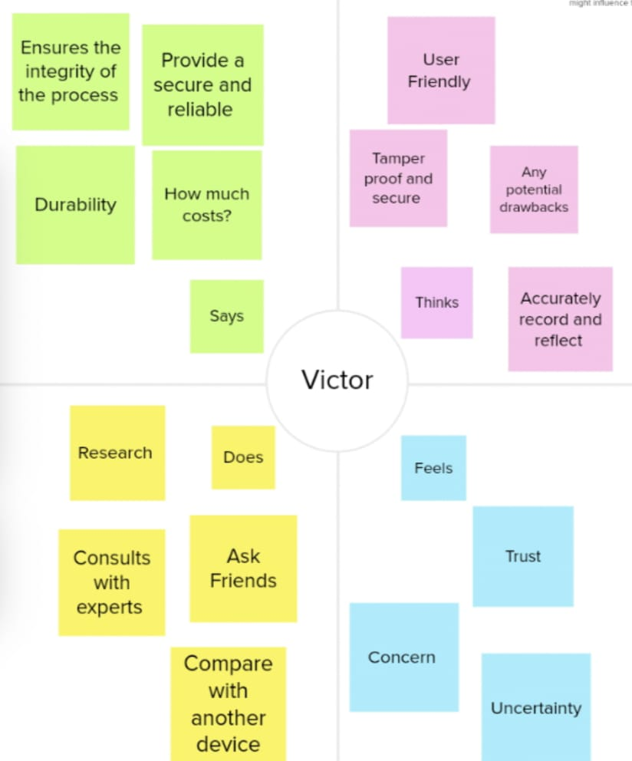

**3.2 Ideation & Brainstorming**

| Date | 30 October 2023 |
| --- | --- |
| Team ID | NM2023TMID07349 |
| Project Name | Electronic Voting Machine |
| Maximum Marks | 4 Marks |

**Brainstorming:**

Brainstorming provides a free and open environment that encourages everyone within a team to participate in the creative thinking process that leads to problem solving. Prioritizing volume over value, out-of-the-box ideas are welcome and built upon, and all participants are encouraged to collaborate, helping each other develop a rich amount of creative solutions.

**Electronic Voting Machine:**

**Step-1: Team Gathering, Collaboration and Select the Problem Statement**

**Step-2: Brainstorm, Idea Listing and Grouping**

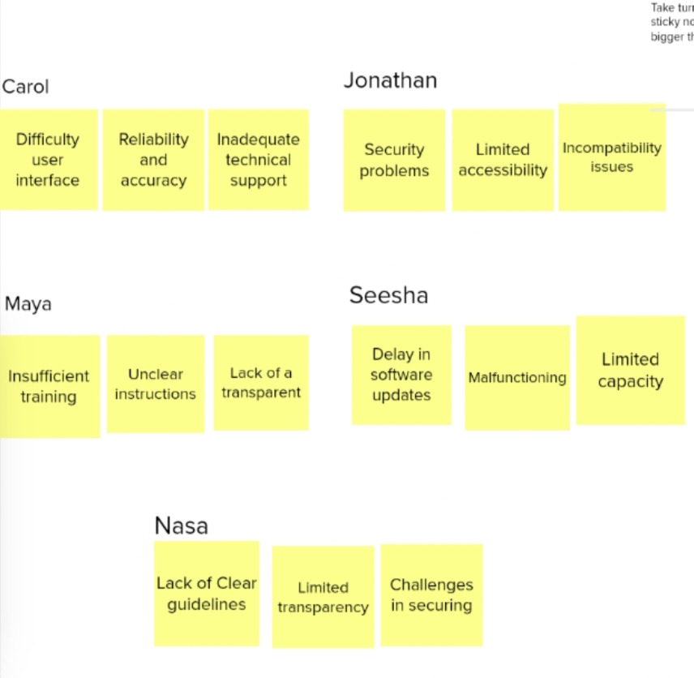

**Step-3: Idea Prioritization**

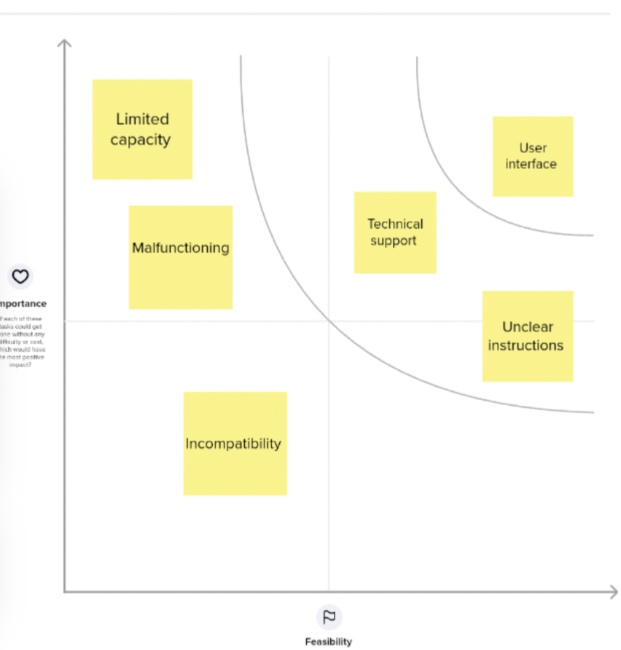

**4. REQUIREMENT ANALYSIS**

| Date | 30 October 2023 |
| --- | --- |
| Team ID | NM2023TMID07349 |
| Project Name | Electronic Voting Machine |

**4.1FUNCTIONAL REQUIREMENTS**

Following are the functional requirements of the proposed solution

|  |  |  |
| --- | --- | --- |
| **FR**  **NO.** | **Functional requirements (Epic)** | **Sub requirement (story/sub-task)** |
| FR-1 | Voter Authentication and Registration | Verify voter identity through biometric authentication. Record voter registration details. |
| FR-2 | Ballot Casting and Recording | Present a user-friendly interface for ballot selection. Allow voters to review their selections before submission. |
| FR-3 | System Reliability and Security | Ensure continuous power supply and backup for uninterrupted voting. |
| FR-4 | Accessibility and Usability | Provide a multilingual interface for diverse voter demographics. |
| FR-5 | Audit Trail and Result Tabulation | Generate a comprehensive audit trail for each voting session. Enable real-time result tabulation with accurate calculations. |

**4.2Non-Functional requirements:**

Following are the non-functional requirements of the proposed solution.

|  |  |  |
| --- | --- | --- |
| **FR No.** | **Non-Functional Requirement** | **Description** |
| NFR-1 | Usability | The interface of the Electronic Voting Machine should be intuitive and easy to navigate, ensuring that voters from all demographic backgrounds can easily cast their vote without confusion or errors. |
| NFR-2 | Security | The Electronic Voting Machine should have robust security measures in place to prevent any unauthorized access or tampering. |
| NFR-3 | Performance | The system should be capable of handling a large number of concurrent users without any degradation in speed or performance. |
| NFR-4 | Compliance | It must adhere to all the relevant legal and regulatory requirements set by the election commission. |
| NFR-5 | Reliability | The system should be to accurately record and store votes even during power fluctuations or temporary outages, ensuring that no data is lost. |

**5. PROJECT DESIGN**

**5.1 Data Flow Diagrams & User Stories**

| Date | 30 October 2023 |
| --- | --- |
| Team ID | NM2023TMID07349 |
| Project Name | Electronic Voting Machine |

**Data Flow Diagrams:**

A Data Flow Diagram (DFD) is a traditional visual representation of the information flows within a system. A neat and clear DFD can depict the right amount of the system requirement graphically. It shows how data enters and leaves the system, what changes the information, and where data is stored.

Example: DFD Level 0 (Industry Standard)

**Electronic Voting Machine:**

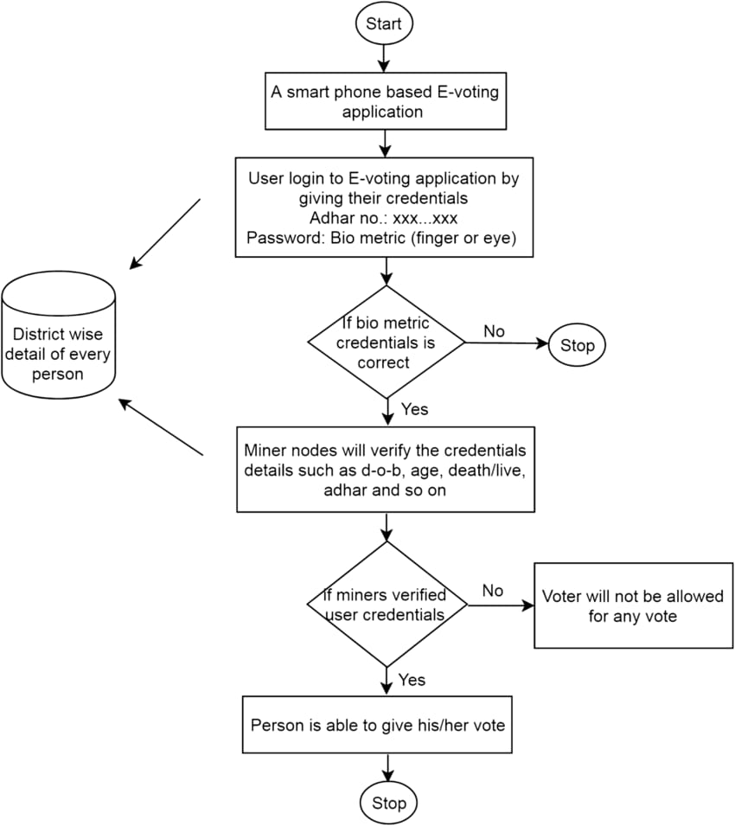**Data Flow Diagram**

**User Stories**

Use the below template to list all the user stories for the product.

| **User Type** | **Functional Requiremet (Epic)** | **User Story Number** | **User Story / Task** | **Acceptance criteria** | **Priority** | **Team Member** |
| --- | --- | --- | --- | --- | --- | --- |
| Customer (Mobile user) | Registration | USN-1 | Excited to participate in the democratic process, the user found the electronic voting machine registration to be surprisingly smooth and intuitive, providing a sense of confidence in the upcoming elections. | Ensure quick and accurate verification. | High | Kevin |
|  |  | USN-2 | Prioritize robust security measures, including encrypted data storage and stringent user verification protocols. | Safety and confidentiality of their personal information. | High | Agnel |
|  |  | USN-3 | Interface should be intuitive and straightforward, ensuring accessibility for users with varying levels of technological proficiency. | The registration process making it convenient and hassle-free for all users. | Low | Abi |
|  |  | USN-4 | Demonstrate high reliability and accuracy, ensuring a smooth and error-free registration experience for users. | Build user’s confidence in its stability and performance, reinforcing trust in the overall voting process. | Medium | Sheak |
|  | Login | USN-5 | Anxious about the security of their vote, the mobile user cautiously approached the electronic voting machine login screen. | Encryption measure and multi-factor authentication. | High | Nekesh |
|  | Dashboard | USN-6 | Eager to stay informed about the election progress, the mobile user accessed the electronic voting machine’s dashboard. | Candidate standings, and any relevant election updates. | Medium | Antony |
| Customer (Web user) | Registration | USN-7 | The user received a prompt confirmation fostering a sense of readiness | Enabling users to quickly locate and initiate the registration | High | Victor |

**5.2Solution Architecture:**

Solution architecture is a complex process – with many sub-processes – that bridges the gap between business problems and technology solutions. Its goals are to:

* Find the best tech solution to solve existing business problems.
* Describe the structure, characteristics, behavior, and other aspects of the software to project stakeholders.
* Define features, development phases, and solution requirements.
* Provide specifications according to which the solution is defined, managed, and delivered.

**Solution Architecture Diagram: Electironic Voting Machine**

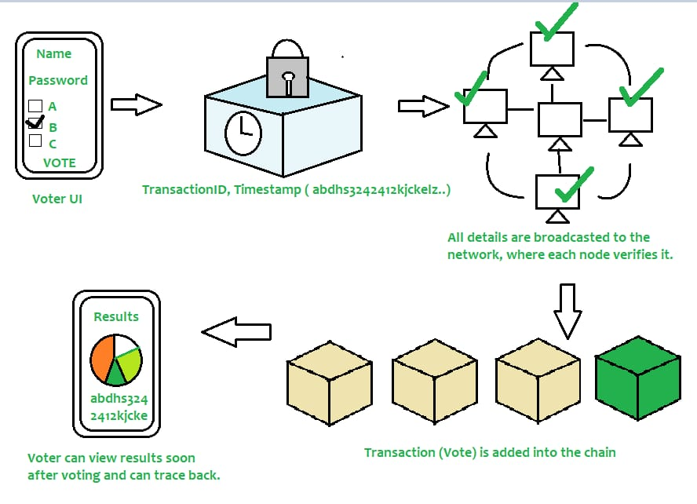

*Figure 1: Architecture and Electronic Voting Machine*

**6. PROJECT PLANNING & SCHEDULING**

**6.1 Technical Architecture**

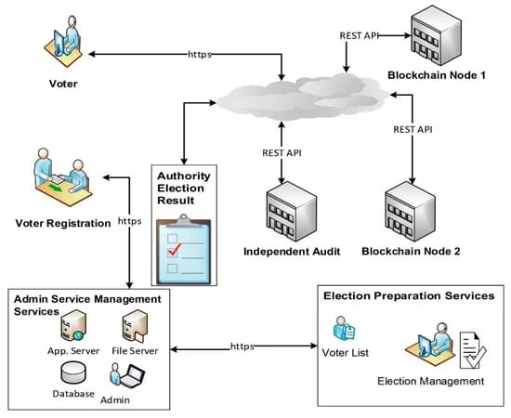

**7. CODING & SOLUTIONING**

**7.1 Feature 1**

**Front End**

**import React from 'react';**

**import ReactDOM from 'react-dom/client';**

**import './index.css';**

**import App from './App';**

**import reportWebVitals from './reportWebVitals';**

**const root = ReactDOM.createRoot(document.getElementById('root'));**

**root.render(**

**<React.StrictMode>**

**<App />**

**</React.StrictMode>**

**);**

**// If you want to start measuring performance in your app, pass a function**

**// to log results (for example: reportWebVitals(console.log))**

**// or send to an analytics endpoint. Learn more: https://bit.ly/CRA-vitals**

**reportWebVitals();**

**7.2 Feature 2**

**<!DOCTYPE html>**

**<html lang="en">**

**<head>**

**<meta charset="utf-8" />**

**<link rel="icon" href="%PUBLIC_URL%/favicon.ico" />**

**<meta name="viewport" content="width=device-width, initial-scale=1" />**

**<meta name="theme-color" content="#000000" />**

**<meta**

**name="description"**

**content="Web site created using create-react-app"**

**/>**

**<link rel="apple-touch-icon" href="%PUBLIC_URL%/logo192.png" />**

**<!--**

**manifest.json provides metadata used when your web app is installed on a**

**user's mobile device or desktop. See https://developers.google.com/web/fundamentals/web-app-manifest/**

**-->**

**<link rel="manifest" href="%PUBLIC_URL%/manifest.json" />**

**<!--**

**Notice the use of %PUBLIC_URL% in the tags above.**

**It will be replaced with the URL of the `public` folder during the build.**

**Only files inside the `public` folder can be referenced from the HTML.**

**Unlike "/favicon.ico" or "favicon.ico", "%PUBLIC_URL%/favicon.ico" will**

**work correctly both with client-side routing and a non-root public URL.**

**Learn how to configure a non-root public URL by running `npm run build`.**

**-->**

**<title>React App</title>**

**</head>**

**<body>**

**<noscript>You need to enable JavaScript to run this app.</noscript>**

**<div id="root"></div>**

**<!--**

**This HTML file is a template.**

**If you open it directly in the browser, you will see an empty page.**

**You can add webfonts, meta tags, or analytics to this file.**

**The build step will place the bundled scripts into the <body> tag.**

**To begin the development, run `npm start` or `yarn start`.**

**To create a production bundle, use `npm run build` or `yarn build`.**

**-->**

**</body>**

**</html>**

**8. PERFORMANCE TESTING**

**8.1 Performace Metrics**

|  |  |
| --- | --- |
| Date | 30 October 2023 |
| Team ID | NM2023TMID06762 |
| Project Name | Electronic Voting System |
| Maximum Marks | 10 Marks |

**Model** **Performance** **Testing:**

Project team shall fill the following information when working for blockchain.

|  |  |  |  |
| --- | --- | --- | --- |
| **S.No.** | **Parameter** | **Values** | **Screenshot** |
| 1. | Information gathering | Setup all the Prerequisite | Description: Tool.JPG |
| 2. | Extract the zip files | Open to vs code | Description: A.JPG |

|  |  |  |  |
| --- | --- | --- | --- |
| 3. | Remix Ide platform  explorting | Deploy The Smart Contract Code Deploy And Run The Transaction. By Selecting The Environment - Inject The Metamask.  (**0x7e8b781b2d1659Dca83479c3899ee4f12f9f415C**) | Description: metamask.JPG |
| 4. | Open file explorer | Open The Extracted File And Click On The Folder.  Open Src, And Search For Utiles.  Open Cmd Enter Commands  1.npm install  2.npm bootstrap  3. npm start | Description: b.JPG  Description: 12.JPG |
| 5. | {LOCALHOST IP ADDRESS} | Copy The Address And Open It  To Chrome So You Can See  The Front End Of Your Project. | Description: 1234.JPG |

**9. RESULTS**

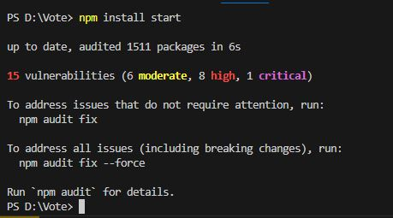**9.1 Output Screenshots**

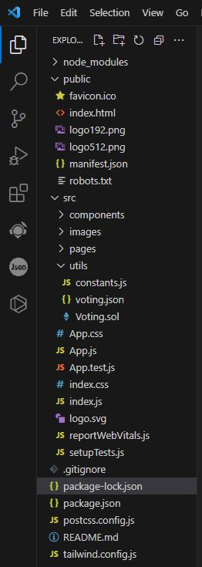

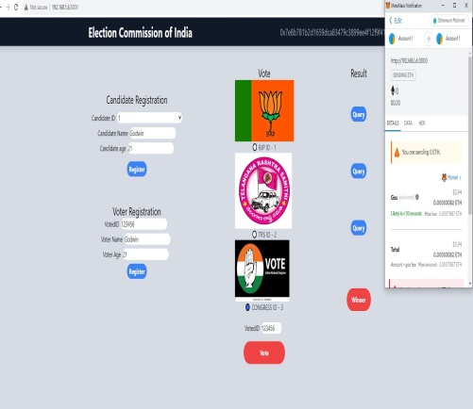

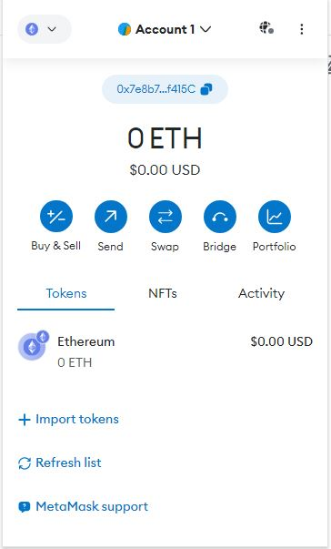

**10. ADVANTAGES & DISADVANTAGES**

**ADVANTAGES**

* + - User cannot know any information about the vote
    - Votes cannot be tampered
    - Blockchain is used for votes

**DISADVANTAGES**

* Wrong inputs will affect the project outputs.
* Internet Connection is mandatory
* The android mobile user will not be able to insert or view details if the server goes down. Thus, there is disadvantage of single point failure.
* Votes/Elections deleted cannot be restored
* Not using any government id
* Cannot register

**11. CONCLUSION**

The recent development in the area of voting system includes Blockchain technology, which not only proved to be time and cost efficient but is also safe and secure, hence is more reliable and precise than the earlier approaches. In this paper we have used blockchain based e- voting using smart contract which includes a set of rules governing the communication and decision on the contract between parties. Various tools like Ganache, Truffle framework, NPM and metamask were used for implementation purpose. As blockchain technology is decentralized due to which tempering and alteration in such system is quite attainable. Our proposed system provides convenience to the voters by allowing them to connect to the system having easy-to-use user interface, through which they can cast their vote by importing their account and can easily review their vote. It creates a sense of trust among voters, that there vote is being computed and kept in a safe custody.

**12. FUTURE SCOPE**

The future scope for electronic voting machines (EVMs) utilizing blockchain technology is promising, as it addresses several challenges associated with traditional voting systems.

**13. APPENDIX**

**Source Code**

import { ethers } from "ethers";

import abi from "./voting.json";

export const contractAddress = "(0x7e8b781b2d1659Dca83479c3899ee4f12f9f415C)";

export const provider = new ethers.providers.Web3Provider(window.ethereum);

export const signer = provider.getSigner();

export const votingContract = new ethers.Contract(contractAddress, abi, signer);

**GitHub & Project Demo Link**

<https://github.com/AbishekM008/NM2023TMID07349>

<https://drive.google.com/file/d/1gD3wF9WF5tvOwxkGPjtfsSZxvhrhZoBd/view?usp=drive_link>